Curriculum Statement of Intent and Implementation:
“The liberating joy found in Literature can be the source of a students’ inspiration for their view of themselves, and the world, for life” – Miss. L. Hagan (Director of English, Lyng Hall)
5-year Curriculum:
Our English curriculum is designed to secure the fundamental skills in year 7 to year 9. Students reiteratively look at the backbone reading and writing skills (AO1-AO6). During our course, students focus on establishing the basic skills, then building on their proficiency and ambition in these specific areas.
Intertwined in the skill-focused lessons will be the development of key English Knowledge. Students are taught specific forms and the relevant characteristics that define them. Furthermore, they develop a knowledge bonk of word classes, literary devices, rhetoric and so on.
The irrefutable necessity of English now and in the beyond:
At Lyng Hall we believe that students should have equitable access to an understanding of the English Language. Competency in this area, we believe, is the backbone to success in all subject areas, and in their future life paths. English provides one of the most significant forums for young people to learn how to communicate ideas – articulating them both verbally and in the written word. Our primary focus therefore is on raising reading age and basic literacy skills. There are 6 reading stages and 5 literacy stages which feature later in this introduction. Groups move through these to develop the relevant competency to access their target levels and navigate their intended routes.
Literacy is a bridge from misery to hope. —Kofi Annan (Ghanaian diplomat who served as the seventh Secretary-General of the United Nations, co-recipient of the 2001 Nobel Peace Prize)
Once you learn to read, you will be forever free. —Frederick Douglass (American social reformer, abolitionist, orator, writer, and statesman)
Effective Teaching for understanding and recall:
Staff at Lyng Hall have an awareness of cognitive load theory and recognise the importance of isolating the powerful knowledge – in addition to knowing how we can drive this forwards in our curriculum.
The English Directorate have taken particular note of the latest Journal from the Chartered College of Teaching. It featured an article which dealt with top tips on avoiding cognitive overload for students with power-points. David Smith (Assistant Head of Teaching and Learning and Teacher of English) outlines the key points to consider in our lessons. Illustrations highlight how this has been embedded within the team so far, and will continue to develop.
1. If you are presenting pictures, diagrams and labels make sure information is in close physical proximity to related information. This avoids split attention deficit.
2. Avoid reading out text that is on a slide. (Unless there is a Tier 3 vocabulary word)
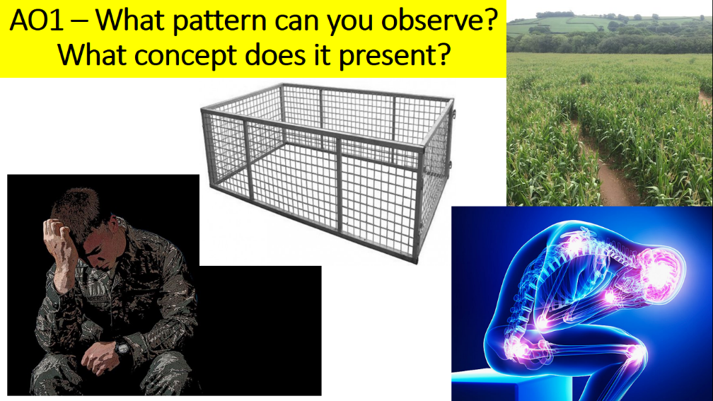
3. Remove any distracting or superfluous images. The only thing on the slide should be linked to powerful knowledge or something that directly supports learning.
4. Use images to support complex and conceptual ideas.
5. If you are going to explain an image on a slide don’t include written text at the same time. Students won’t take both in.
6. Never expect students to be reading the board, or indeed anything, if you are talking at the same time.
7. Reveal tasks, processes or stages one at a time ON THE SAME SLIDE. Not on slide after slide.
8. Remember that spoken words and retention of information on slides is fleeting unless then supporting by work/learning/tasks to embed knowledge.
9. Have you sat at the back of the room and checked information, colours, font size, literacy, where you have used complex vocabulary that needs explaining.
Each medium term scheme sets out the threshold and horizon skill that is the aim for that block of learning. These skills are repeated at least three times through KS3 to ensure the learning is deepened and refined. Within the schemes, bespokely shaped to each group, each lesson has a specific threshold and horizon ‘Big Ideas’ question. These collectively work together to ensure the overarching skills aim is met. These horizon skills are stepped to constantly challenge the students towards a future goal.

Developing Cultural Capital – an enriching curriculum
A particular concern of the directorate is to promote a cultural understanding of both self, and the world. In order to achieve this complex outcome the curriculum looks to repeatedly explore some challenging concepts, and provide students with the forum not only to begin their understanding of them, but additionally to articulate their individual responses to them. This journey of interpretation is reflected in both the curriculum and the enrichment programme. Why?
“To establish stable schemas in students’ long-term memory that reduce cognitive load” (Mary Myatt, The Curriculum, 2018)
“Cultural capital takes one tangible form: a pupil’s vocabulary” (Matthew Bromley, ‘Pupil Premium: closing the vocabulary gap SecEd, 2018)
“To provide students with Hirsch’s ‘mental Velcro.’ (Josie Stacks, Is this presumed knowledge which I see before me? 2019)
The table highlights one possible journey a student’s understanding can follow on one concept. In different ways, the ideas are revisited to not only concept but to broaden, and deepen, an understanding of how these patterns are observed in the world. More specifically how Literature is essentially a portal we can use to interpret the world through time.
CURRICULUM COHESION | Unifying concepts | Mental scaffolding | Cultural literacy | Broader vocabulary | Powerful Knowledge to be recalled
Writing Wrongs –  Year 7-8 | Inequality  Injustice  Totalitarian  Communism  Oppression  Socialism  Capitalism | I believe this …  Exposing this idea…  Articulating perspectives:  State  Justify  Apply | Develop awareness/share opinions of global issues | Perspective  Interpretation | Types of conflict  Concepts of power  Social responsibilities
Historical Non-Fiction –  Year 8 | Social Injustice  Class System  Gender equality  Inequality  Types of war and conflict  Racism | I can observe…  If we contrast centuries it is possible to see…  Observing repeating patterns between different eras… | Cyclical nature of history  Develop awareness of injustice for specific races/religions  Global issues in different eras of time | Historical significance  Patterns in history  Observe  Perspective | Class systems  Political systems  Social responsibilities  Types of war and conflict
19th Century –  Year 8 | Inequality  Injustice  Poverty  Class systems  Gothic conventions  Religion  Atheism  Evolution of Science  Spiritualism  Capitalism  Socialism  Oppression  Darwinism  Industrial revolution | Patterns/changes in time  Since this time beliefs have now changed to…  During this era it was believed that …  The text exposes the … of the time. | Develop understanding of 19th Century British society, culture and norms.  Express an understanding of the developments of society, culture and norms.  Contrast the society, culture and norms of the 19th century to modern society.  Understand the factors that have developed changes in our society, culture and norms. | Historical significance  Impact  Interpretation  Perspective  Patterns in history | Poverty  Social responsibilities  Concepts of power  Class systems  Understanding of older English language styles  Wide contextual understanding for unseen language paper
Gothic –  Year 7 | Romanticism  Transgression  Gender  Supernatural  Oppression  Religion  Science  Death and tragedy  symbolism | Patterns and changes in time highlight…  In this era it was believed…  The symbolism which is explored….  The oppressive nature of society is signified… | Develop awareness/  Understanding today’s society  Understanding the literary movement of the time  Identifying how it has impacted later genres  Understanding archaic language | Perspective  Interpretation  Significance  Impacts | Social responsibilities  Religious conflict  Science and technological advances

