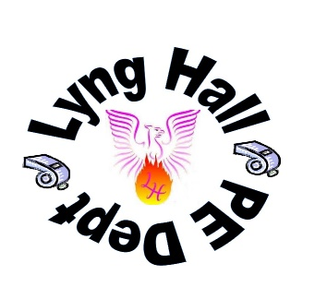
Name ____________
My Yr 7 PE Profile

H

H
H
“You don’t have to be great to start, but you have to start to be great”

 | Bronze | Silver | Gold
  Head | To know why a warm up is necessary | To identify some muscles of the body | To understand the benefits to following an active, healthy lifestyle on physical, mental and social well-being
 | To name 2 rules of a sport | To name 2 rules in a variety of sports | To be able to recognise the key rule violations
 | To know that heart rate changes as a result of exercise | To state different ways the body responds to exercise | To explain how the body responds to exercise
 | To make simple judgements on performance with guidance | To identify strengths & weaknesses of self & others with guidance | To identify a strength & weakness of self & others
 | To identify problems | To state different ways the body responds to exercise | To explain how the body responds to exercise
 | To show an awareness of basic tactics & strategies | To identify strengths & weaknesses of self & others with guidance | To identify a strength & weakness of self & others
  Heartd | To demonstrate communication skills within discussions and activities | To display clear communication skills, empathy and patience | To inspire and motivate others to participate and progress
 | To know how to respect equipment and others | To develop respectful relationships with peers | To be respected and respectful, whilst developing a positive working relationship with staff and students across the school
 | To lead a warm up to a partner | To lead a warm up to a small group of peers with some confidence | To be confident and competent when leading large groups of performers
 | To sometimes demonstrate resilience and a good work ethic | To give 100% effort to several activities and often resilient when faced with challenging tasks. | To be consistently hardworking, resilient and eagerly accept challenges
  Hands | To know the basic skills | To select appropriate skills | To be able to consistently select & apply appropriate skills
 | To be able to complete a 2-minute run and sustain a basic level of technique and physical fitness | To be able to complete a 5-minute run and sustaining a developing level of physical fitness in some activities. | To be able to complete a 10-minute run, sustaining good levels of endurance-based fitness. To be able to apply this over a broad range of activities.
 | To perform simple skills in isolation with some success | To perform skills in moderately pressured practices with some success | To consistently perform skills in challenging activities/competition.
 | To be able to replicate simple actions | To be able to replicate simple actions with expression & timing | To be able to choreograph a sequence with expression and timing
 | To identify changes in a situation with support | To identify changes in a situation with a prompt | To recognise how situations change independently
 | To understand what is required for maximum levels in different activities | To be able to sustain performance in relation to: speed, height, strengths & stamina | To be able to sustain performance in relation to speed, height, strengths & stamina in most activities
Year 7 | Pupil Target |  | Current Grade
Head   | Knowledge ▪ Understanding ▪ Analysis ▪ Feedback ▪ Rules ▪ Responsibility
 | WWW… |  | EBI…
Heart   | Confidence ▪ Leadership ▪ Respect ▪ Communication ▪ Resilience ▪ Effort
 | WWW… |  | EBI…
Hands   | Physical Ability ▪ Fitness ▪ Competition ▪ Technique ▪ Tactics ▪ Problem Solving
 | WWW… |  | EBI…

