Provider access policy statement
Lyng Hall School

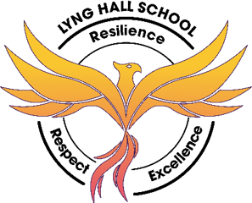

Approved by: | D.Fowler | Date: October 2026
Last reviewed on: | October 2026
Next review due by: | October 2027

Contents
1. Rationale 2
2. Statutory requirements 3
3. Pupil entitlement 3
4. Management of provider access requests 4
5. Pupil Destinations …………………………………………………………………………………………………………………………………………5
6. Complaints…………………………………………………………………………………………………………………………………………………….5
7. Monitoring arrangements……………………………………………………………………………………………………………………………..5

1.Rationale
High quality careers education and guidance in school or college is critical to young people’s futures. It helps to prepare them for the workplace by providing a clear understanding of the world of work including the routes to jobs and careers that they might find engaging and rewarding. It supports them to acquire the self-development and career management skills they need to achieve positive employment destinations. This helps students to choose their pathways, improve their life opportunities and contribute to a productive and successful economy.
As the number of apprenticeships rises every year, it becomes increasingly important that all young people have a full understanding of all the options available to them post-16 and post-18 including wider technical education options such as T-Levels and Higher Technical Qualifications.
Lyng Hall School is committed to ensuring there is an opportunity for a range of education and training providers to access students, for the purpose of informing them about approved technical education qualifications and apprenticeships. Lyng Hall School is fully aware of the responsibility to set students on the path that will secure the best outcome, which will enable them to progress in education and work and give employers the highly skilled people they need. That means acting impartially, in line with the statutory duty, and not showing bias towards any route, be that academic or technical.
Lyng Hall School endeavours to ensure that all students are aware of all routes to higher skills and are able to access information on technical options and apprenticeships (The Department of Education, July 2021: “Baker Clause”: supporting students to understand the full range of education and training options, and the Provider Access Legislation, January 2023).

2. Statutory requirements
Schools are required to ensure that there is an opportunity for a range of education and training providers to access students in years 8 to 13 for the purposes of informing them about approved technical education, qualifications or apprenticeships.
Schools must provide a minimum of 6 encounters with technical education or training providers to all pupils in years 8 to 13 (see more detail in section 3.1 below).
Schools must also have a policy statement that outlines the circumstances in which education and training providers will be given access to these pupils.
This is outlined in:
- Section 42B of the Education Act 1997
- Education and Skills Act 2008
- The School Information (England) Regulations 2008
- The Skills and Post-16 Education Act 2022
- Guidance from the Department for Education (DfE) on careers guidance and access for education and training providers
This policy shows how our school complies with these requirements.

3. Pupil entitlement
All pupils in years 8 to 13 at Lyng Hall School are entitled to:
- Find out about further education training, technical education qualifications and apprenticeship opportunities as part of our careers programme, which provides information on the full range of education and training options available at each transition point
- Hear from a range of local providers about the opportunities they offer, including technical education and apprenticeships, e.g. through activities and events such as options events, assemblies and taster events
- Understand how to make applications for the full range of academic and technical courses
- Have a minimum of 6 encounters with providers
These encounters must happen for a reasonable period of time during the standard school day.
As a school we can provide complementary experiences but encounters outside of school hours won't count towards these requirements.
Access to providers is available and promoted to allow all pupils to access information about other providers of further education and apprenticeships. We are committed to encouraging all pupils to make decisions about their future based on impartial information.

3.1 Meaningful encounters with providers
Our school is committed to providing meaning encounters for all pupils.
A meaningful encounter:
- Is where the pupil can explore what it is like to learn, develop and succeed in that environment
- Involves meeting both staff and learners/trainees
- Has a clear purpose
- Is underpinned by learning outcomes that are appropriate to the needs of the pupil
- Involves a 2-way interaction between the pupil and the provider
- Includes information about the provider, such as their recruitment and selection processes, the qualifications that provider offers and the careers these could lead to
- Describes what learning or training with the provider is like
- Is followed by opportunities for the pupil to reflect on the insights, knowledge or skills gained through the encounter

4. Management of provider access requests
4.1 Procedure
A provider wishing to request access should contact Mr Z Ahbedin – Careers Leader.
Telephone: 02476 724960 ext 4123
Email: zahbedin@lynghallschool.co.uk
4.2 Information we ask from providers
As a school we ask each provider to provide the following information for our pupils:
- Information about your provision and the approved qualifications or apprenticeships you offer
- Information about what careers those qualifications and apprenticeships can lead to
- What learning or training with you is like
- Answers to any questions from pupils
4.3 Opportunities for access
There are a number of events, integrated into our careers programme, that offer providers an opportunity to come into school to speak to pupils and/or their parents/carers.
Please speak to Mr Z Ahbedin – Careers Leader - to identify the most suitable opportunity for you.
4.4 Live online encounters
We will consider requests for live online encounters with providers, which may be broadcast into classrooms or the school assembly hall. We will need to carry out technology checks in advance to make sure systems are compatible.
4.5 Granting and refusing provider access requests
Each access request will be considered on a case-by-case basis.
We will grant access requests where there is opportunity for a positive contribution to our careers programme.
4.6 Safeguarding
Our safeguarding/child protection policy outlines the school’s procedure for checking the identity and suitability of visitors. You can find the policy on the school website – www.lynghallschool.co.uk
Education and training providers will be expected to adhere to this policy.
4.7 Premises and facilities
We will provide an appropriate room or assembly hall, with the necessary equipment providers require to carry out their visit effectively – details will be agreed with the provider.
Providers are welcome to leave a copy of their prospectus or other relevant course literature with Mr Z Ahbedin – Careers Leader.
Providers will be met and supervised by a member of staff who will facilitate their visit.

5. Pupil destinations
Last year, our year 11 pupils moved to a range of providers after school:
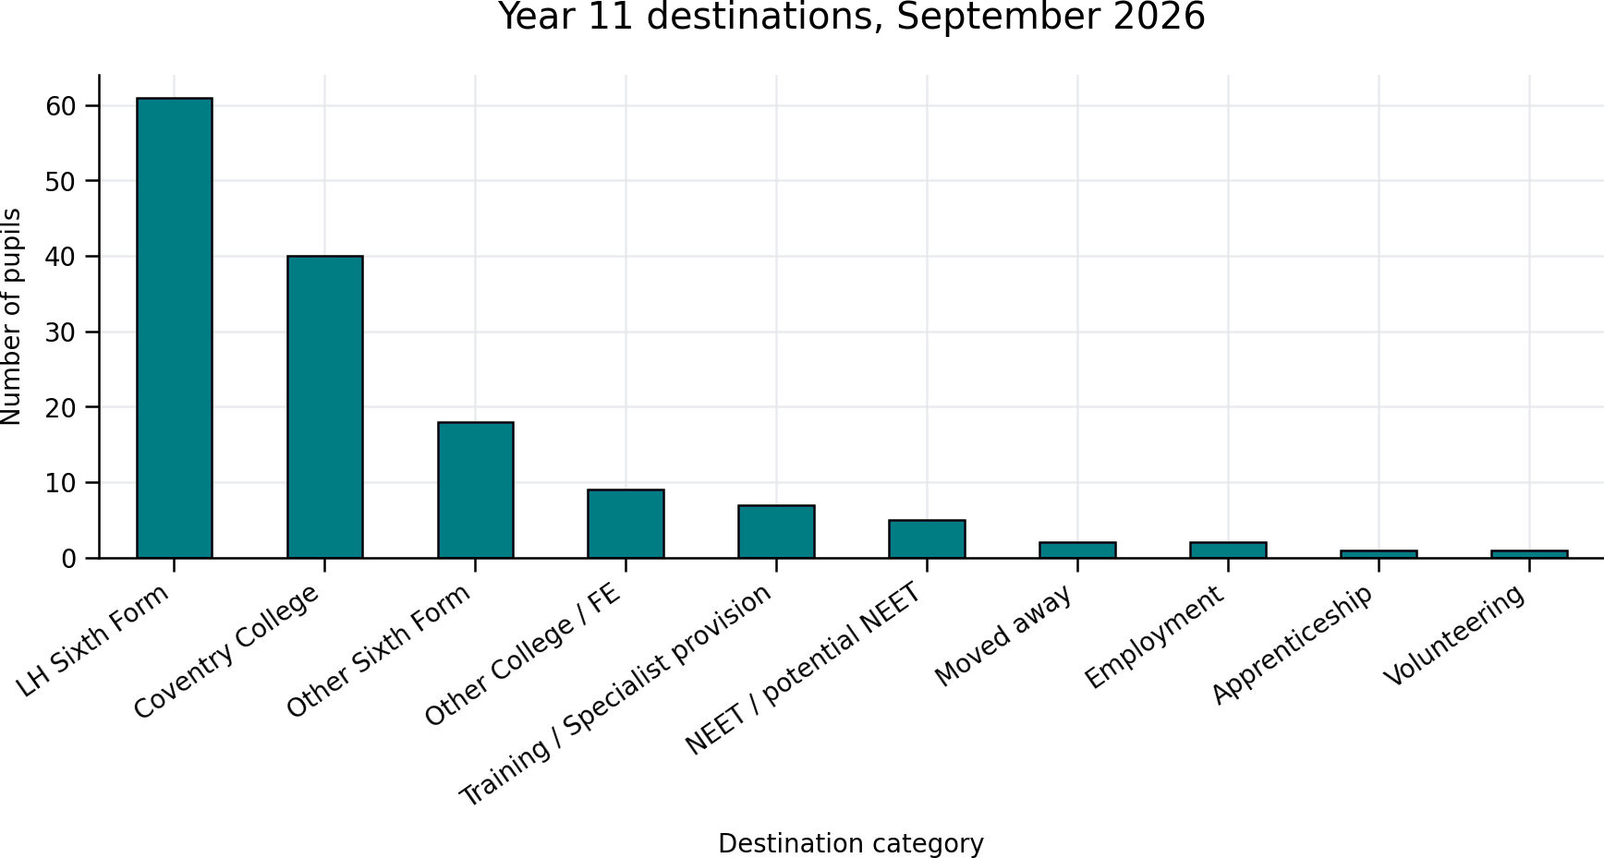

Last year, our year 13 pupils moved to a range of providers after school:
Destination | Number | Percentage
University (UNI) | 48 | 66.7%
Employment (EMP) | 11 | 15.2%
Further support required (INT) | 4 | 5.6%
Gap Year (GAP) | 5 | 6.9%
Further Education (FE) | 3 | 4.2%
Apprenticeship (APP) | 1 | 1.4%
Total | 72 | 100%

6. Complaints
Any complaints related to provider access can be raised following the school complaints procedure as detailed on the school website – www.lynghallschool.co.uk

7. Monitoring arrangements
The Policy is monitored and evaluated annually by the Senior Leadership Team and the Local Governing Body.

