Pupil premium strategy statement – Lyng Hall School
2025-2026

This statement details our school’s use of pupil premium funding to help improve the attainment of our disadvantaged pupils.
It outlines our pupil premium strategy, how we intend to spend the funding in this academic year and the outcomes for disadvantaged pupils last academic year.

School overview
Detail | Data
Number of pupils in school (yrs 7-11) | 820
Proportion (%) of pupil premium eligible pupils | 43.3%
Academic year/years that our current pupil premium strategy plan covers (3-year plans are recommended – you must still publish an updated statement each academic year) | 2025-2026  2026-2027  2027-2028
Date this statement was published | 22nd December 2025
Date on which it will be reviewed | September 2026
Statement authorised by | Leah Martindale, Headteacher
Pupil premium lead | Dianne Fowler,  Assistant Headteacher
Governor / Trustee lead | Ghulam Vohra

Funding overview
Detail | Amount
Pupil premium funding allocation this academic year | £381,625
Pupil premium funding carried forward from previous years (enter £0 if not applicable) | £0
Total budget for this academic year  If your school is an academy in a trust that pools this funding, state the amount available to your school this academic year | £381, 625

Part A: Pupil premium strategy plan

Statement of intent
Our intention is that all students at Lyng Hall School, irrespective of their background or the challenges they may face, make excellent progress and achieve high attainment across the curriculum.

The focus of our pupil premium strategy is to support disadvantaged pupils to achieve the above goal through a wide range of strategies. We want to ensure that any barriers to students’ learning are removed and that all students can achieve the best possible outcomes and successfully progress into post-16 studies.

The main focus of our approach is high quality teaching and learning. In the EEF 3- tiered approach this is highlighted as a key ingredient of success and therefore a proportion of the pupil premium funding is allocated to this area, it will also benefit non-disadvantaged students as well. There is also a relentless focus on individual students eligible for pupil premium funding at a whole school, department and classroom level providing targeted academic support where appropriate. The third tier highlights specific interventions and wider strategies that are used on a personalised basis to remove barriers to learning. Regular pupil premium strategy group meetings with all relevant stakeholders ensure a holistic approach to these interventions.

Our approach will be driven by data, research and knowledge of individual student needs. The whole school focus on data driven instruction and responsive teaching will ensure:

● Disadvantaged students are supported and challenged as necessary in every lesson and make excellent progress
● Use data to ensure timely interventions are put in place.
● A whole school approach in which all staff take responsibility for disadvantaged pupils’ outcomes and raise expectations of what they can achieve.

Challenges
This details the key challenges to achievement that we have identified among our disadvantaged pupils.

Challenge number | Detail of challenge
1 | Attainment – there remains a significant gap between the attainment of PP and non PP students, particularly in English and Maths – 42% of non PP students achieved English & Maths 4+ whereas only 23% of PP students achieved the same.
2 | Late arrivals to school – in 2024-2025, 5.37% of late arrivals compared to a Coventry average of 4.43% and a national average of 2.86%. The % for PP students was 6.12%
3 | Attendance – yearly attendance figure for Lyng Hall for 2024-2025 was 88.7% compared to a Coventry average of and a National average of . For PP students the average was lower at 85.5%
4 | Literacy - levels on entry to the school are low, with reading ages below expectations, in September Year 7 arrived with over 33% being assessed as below expected expectations in KS2 SATs reading paper.
5 | SEND – Attainment of SEND student remains lower than rest of cohort – 17% achieved 4+ in Maths and English in 2024-2025. Whilst it has improved from 11% in 2024 there are still improvements to be made.

Intended outcomes
This explains the outcomes we are aiming for by the end of our current strategy plan, and how we will measure whether they have been achieved.
Intended outcome | Success criteria
Attainment gap to narrow. | 25/26 data shows a narrowing of the gap in attainment scores in maths and English between PP and non PP students. This gap reduces in 26/27 and again in 27/28
Number of late arrivals to reduce. PP lateness to align with rest of the school. | Lateness to school reduced from 5.37%. PP lateness reduced from 6.12%.  Lateness continues to reduce in subsequent years.
Attendance to improve – PP attendance to align with rest of the school. | Whole school attendance increased from 88.7%. PP students attendance improved from 85.5%  Attendance continues to improve and the gap narrows between PP and non PP students in subsequent years.
Levels of literacy to improve, including reading ages. | Reading ages show improvement with regards closing the gap and chronological age. NGRT tests show improved reading scores.
The gap for students with SEND is reduced. Literacy levels are improved. | NGRT show reading levels for SEND students have improved.  Attainment of SEND year 11 students improved from 17% achieving English and Maths 4+

Activity in this academic year
This details how we intend to spend our pupil premium funding this academic year to address the challenges listed above.

Teaching (for example, CPD, recruitment and retention)
Budgeted cost: including Associate Teaching staff and TEFL teaching staff- £200,000
Activity | Evidence that supports this approach | Challenge number(s) addressed
Teaching staff provide excellent feedback to students. Training and development is focused on responsive teaching to support this activity. | Feedback is information given to the learner about the learner’s performance relative to learning goals or outcomes. It should aim to (and be capable of producing) improvement in students’ learning. Providing feedback is a well evidenced and has a high impact on learning outcomes. Effective feedback tends to focus on the task, subject and self-regulation strategies: it provides specific information on how to improve.  https://educationendowmentfoundation.org.uk/education-evidence/teaching-learning-toolkit/feedback | 1, 4, 5
Training and development of teachers is focused on a clear programme of instructional coaching and data driven instruction. | Instructional coaching is a nationally recognised technique to rapidly improve teaching and learning for all staff. Together with data driven instruction this will enable teaching staff to identify students quickly and ensure strategies in class and externally are in place to improve progress and attainment.  The link below provides evidence from Steplab regarding the effectiveness of instructional coaching.  Beginner’s Guide to Instructional Coaching | 1, 4,5
Foundation and TEFL Directorates  Provision within each year group for very vulnerable students - highly personalised curriculum. Smaller class sizes, with high staff: student ratio. One-to-one and small group provision. Bespoke provision for up to 40 pupils across all years who arrive unable to speak English, delivered by teachers who speak Romanian, Slovakian, Polish, Russian. | EEF T&L Toolkit Guide to the Pupil Premium  Reducing Class Size  Targeted academic support including small group tuition  Teaching Assistant Interventions  Individualised Instruction | 1, 4

Targeted academic support (for example, tutoring, one-to-one support, structured interventions)
Budgeted cost: £130,000
Activity | Evidence that supports this approach | Challenge number(s) addressed
Literacy based programmes / initiatives  Accelerated Reader  Talk 4 Writing  Myon Digital library  Reciprocal Reading embedded across the curriculum  NGRT testing | A targeted programme of reading for all disadvantaged students to improve reading comprehension and target vocabulary gaps. Reading comprehension strategies can have a positive impact on pupils’ ability to understand a text, and this is particularly the case when interventions are delivered over a shorter timespan:  https://educationendowmentfoundation.org.uk/evidence-summaries/teaching-learning-toolkit/reading-comprehension-strategies/ | 1, 4, 5
Mentoring of targeted DA students by key members of staff across the academic year. | Mentoring in education involves pairing young people with an older peer or adult volunteer, who acts as a positive role model. In general, mentoring aims to build confidence and relationships, to develop resilience and character, or raise aspirations, rather than to develop specific academic skills or knowledge  https://educationendowmentfoundation.org.uk/education-evidence/teaching-learning-toolkit/mentoring | 1,2,3,4,5
Students who have SEND and are disadvantaged receive targeted support by key members of inclusion team. | Mentoring | EEF | 1,2,3,4,5
School Careers  Advisor  Students receive targeted and dedicated careers advice. | Ensuring that students have the knowledge and skills to progress towards their aspirations is likely to be more effective than intervening to change the aspirations themselves. The dedicated careers support will ensure students have the knowledge and skills needed to progress towards their aspirations.  https://educationendowmentfoundation.org.uk/education-evidence/teaching-learning-toolkit/aspiration-interventions | 1
PiXL strategies, including; exam support resources; PiXL subject support; | Pixl insights - empower learners from disadvantaged backgrounds | 1, 4, 5
Before and After school  Enrichment/catch up/homework  club/breakfast club | The Department for Education (DfE) notes that schools in their early adopter program for universal free breakfast clubs report improvements in punctuality and attendance. | 1, 2, 3, 4, 5

Wider strategies (for example, related to attendance, behaviour, wellbeing)
Budgeted cost: £ 50,000
Activity | Evidence that supports this approach | Challenge number(s) addressed
Transition  Year 6-7  Significant time spent by staff in primary schools working with disadvantaged students in preparation for them joining us in Y7  Y11 – Y12  Advice and counselling for PP students re the correct pathway for them at 16+. Revision of our own L2 and L3 courses to accommodate need. | Most research into transition recognises that transition puts enormous demands on to children – socially, linguistically, emotionally, academically and practically. Some children will inevitably find transition more difficult than others, however this can be mitigated if transition is a priority.  improving-school-transitions-for-health-equity.pdf | 1, 2, 3, 5
Remove financial barriers to learning, linked to “Cost of the School Day report.”  Funding for educational visits/uniform/equipment/revision guides. | Cost of the School Day Report  Arts participation | EEF  School uniform | EEF | 2, 3
Attendance & punctuality rewards and intensive data monitoring.  Working with students and families to reduce incidences of lateness. |  | 1, 2,

Total budgeted cost: £ 380,000

Part B: Review of the previous academic year

Outcomes for disadvantaged pupils
The data below shows that although the A8 score for PP students increased by a very small amount, there is still a long way to go.
Within school it has been highlighted that a lot of the issues revolve around attendance and lateness which is why the focus of our PP strategy has evolved this year for 2025-2026 to include these key factors / barriers.
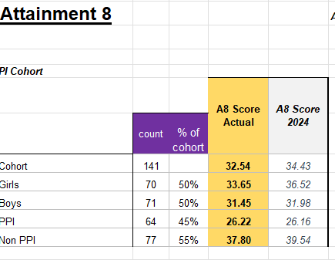
2024-2025

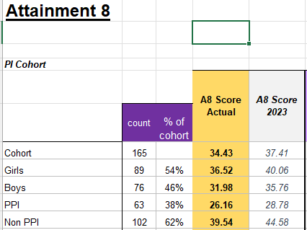
2023-2024

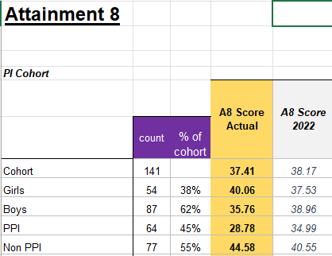
2022-2023

Externally provided programmes
Please include the names of any non-DfE programmes that you used your pupil premium to fund in the previous academic year.
Programme | Provider
N/A

